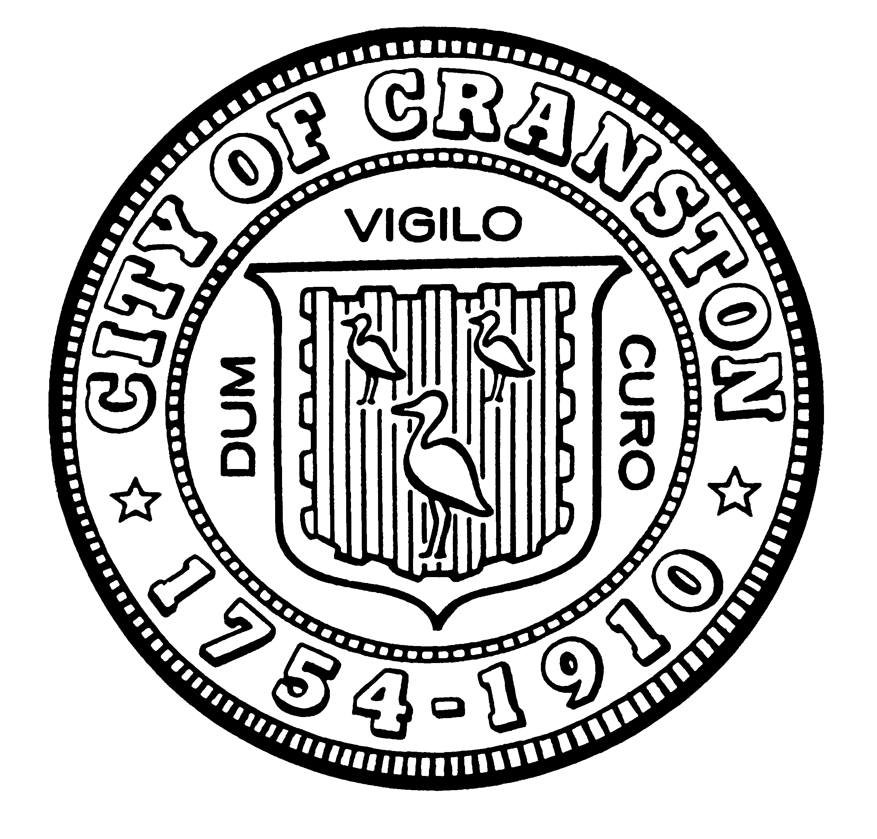

HOUSING COMMISSION

Annette Mann Bourne, Chair
Laura-Jean Ferranti, Community Development (interim)
Amy Rainone, Secretary
Jason Case
Frank DiZoglio III
Joanne McGunagle, CCAP
Jason M. Pezzullo, Planning Director
Robert Santurri Jr, OneCranston Health Equity Zone
Derik Tutt

WEDNESDAY August 3, 2022 @ 5:30 P.M.
Cranston City Hall, 869 Park Avenue
3rd Floor Conference Room

MONTHLY MEETING- MAY AGENDA

- Approval of minutes of July 6, 2022 meeting (for vote)
- Overview of the housing legislation passed in 2022 (for discussion)
- New business (for discussion)

“Individuals requesting interpreter services for the hearing-impaired must notify the Office of the City Clerk at 461-1000 Ext. 3197 seventy-two (72) hours in advance of the hearing date.”

